

Pandas Project

**telco Customer churn analysis**

**Project For Resume**



**Created by: Ghulam Hussain**

[**https://github.com/ghulamhussainkhuhro**](https://github.com/ghulamhussainkhuhro)**/telco-customer-churn-analysis**

January 15, 2025

**Customer Churn Analysis: Insights and Findings**

**Introduction**

In a rapidly evolving market, retaining customers is as crucial as acquiring new ones. Customer churn, defined as the percentage of customers who discontinue their subscription or relationship with a company, directly impacts revenue and long-term growth. This analysis explores the patterns and reasons behind customer churn using a structured data-driven approach, aiming to identify actionable insights for improving retention strategies.

**Data Overview**

The dataset used for this analysis consisted of customer demographic details, account information, and service usage metrics. Initial data preprocessing included:

* **Handling Missing Values**: Replaced missing values in the TotalCharges column with 0 and converted the column to a float type.
* **Checking for Duplicates**: Ensured unique customer records by validating no duplicates in the customerID column.
* **Data Transformation**: Converted binary fields like SeniorCitizen to descriptive categories (yes/no) for better interpretability.

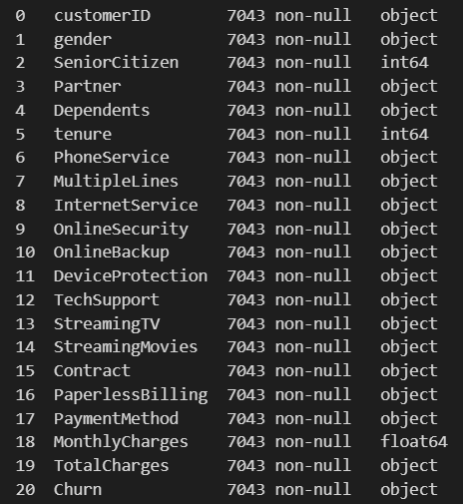

**Key Insights and Visualizations**

**1. Overall Churn Rate**

* **Finding**: The pie chart revealed that **26.54% of customers had churned**, highlighting a significant retention issue.

**2. Churn by Demographics**

* **Gender**: Male and female customers exhibited similar churn rates, suggesting gender-neutral drivers.

* **Senior Citizens**: A higher churn rate was observed among senior citizens compared to non-senior citizens.

* + **Action**: Develop tailored plans and support services for senior customers to address their specific needs.

**3. Tenure and Churn**

* **Observation**: Customers with shorter tenure were more likely to churn.

* + **Action**: Implement loyalty programs or early-stage engagement initiatives to retain new customers.

**4. Contract Types**

* **Insight**: Customers with month-to-month contracts had the highest churn rates compared to those with one-year or two-year contracts.

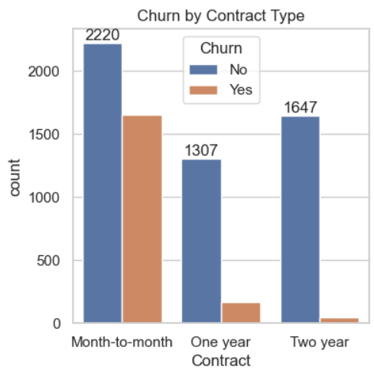

* + **Action**: Incentivize longer-term contracts through discounts or added benefits.

**5. Service-Specific Observations**

* **Phone Service**:
  + Customers with phone services were more likely to churn.
  + **Action**: Enhance phone service quality and provide value-added features.
* **Internet Service**:
  + Fiber optic internet users had higher churn rates compared to DSL users.
  + **Action**: Address reliability and pricing concerns for fiber optic services.
* **Online Security and Backup**:
  + Customers without these add-ons exhibited higher churn rates.
  + **Action**: Bundle these services or offer promotional deals to encourage adoption.
* **Streaming Services**:
  + Churn rates among streaming service users were slightly higher, suggesting potential dissatisfaction.
  + **Action**: Conduct customer surveys to enhance content quality and variety.
* **Technical Support**:
  + Lack of technical support significantly correlated with higher churn rates.
  + **Action**: Invest in proactive tech support and troubleshooting resources.

**6. Payment Methods**

* **Electronic Checks**: Showed the highest churn rate, indicating potential dissatisfaction with this payment method.

* **Automatic Payments**: Customers using automatic payments (via bank transfer or credit card) had significantly lower churn rates.
  + **Action**: Encourage customers to switch to automatic payment methods through incentives.

**Recommendations**

1. **Service Bundles**: Create comprehensive service packages combining online security, backup, device protection, and technical support.
2. **Customer Feedback**: Regularly collect and analyze customer feedback to identify and address pain points.
3. **Retention Strategies**: Offer targeted retention plans, including discounts, for at-risk customers.
4. **Enhance Services**: Focus on improving high-churn services such as fiber optic internet and streaming platforms.
5. **Promote Long-Term Contracts**: Provide financial incentives to encourage customers to commit to longer contracts.
6. **Payment Method Optimization**: Advocate for automatic payment methods by highlighting convenience and benefits.

**Conclusion**

This analysis sheds light on critical factors influencing customer churn. By addressing these insights through targeted strategies, companies can significantly improve customer retention and build long-term loyalty.